Week 01
Question 1:
This is a simple challenge to help you practice printing to stdout.
We're starting out by printing the most famous computing phrase of all time! In the editor
below, use either printf or cout to print the string Hello, World! to stdout.
Input Format
You do not need to read any input in this challenge.
Output Format
Print Hello, World! to stdout.
Sample Output 1
Hello, World!
Program:
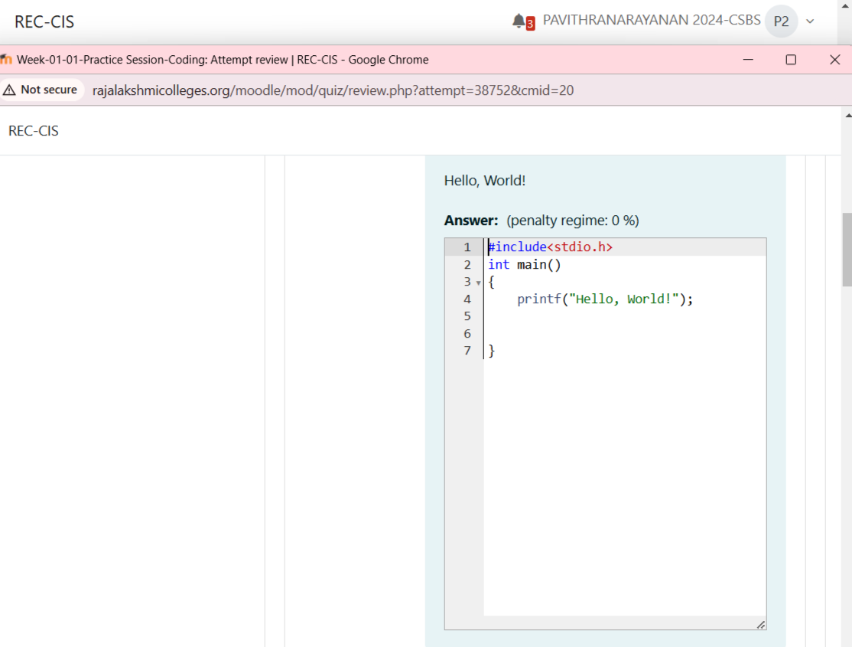
Output:
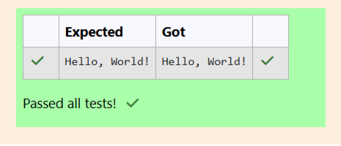
Question 2:
This challenge will help you to learn how to take a character, a string and a sentence a input in C. To take a single character ch as input, you can use scanf("%c", &ch); and printf("%c", ch) writes a character specified by the argument char to stdout:
char ch;
scanf("%c", &ch);
printf("%c", ch);
You have to print the character, ch, in the first line. Then print s in next line. In the last line print the sentence, sen.
Input Format
First, take a character, ch as input. Then take the string, s as input. Lastly, take the sentence sen as input
Output Format
Print three lines of output. The first line prints the character, ch. The second line prints the string, s. The third line prints the sentence,sen.

Program:
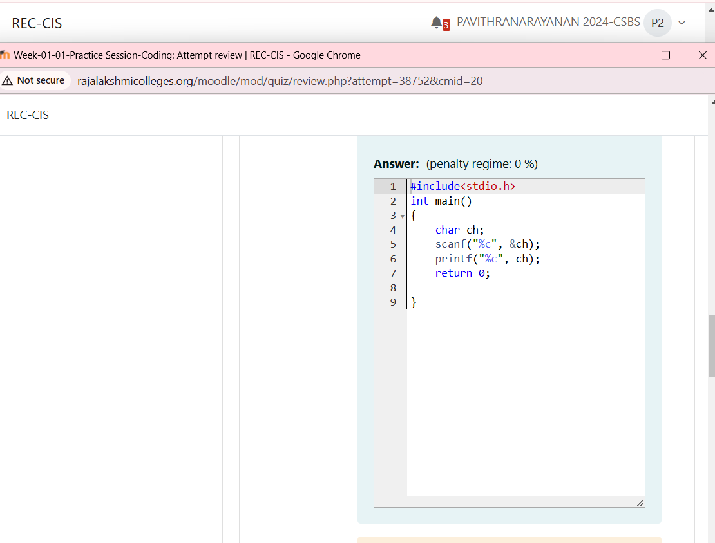

Output:
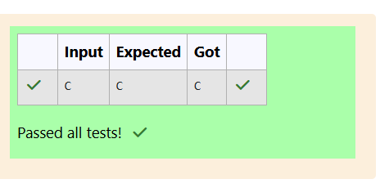
Question 3:
The fundamental data types in c are int, float and char. Today, we're discussing int and float data types.The printf() function prints the given statement to the console. The syntax is printf("formatstring",argument_list);. In the function, if we are using an integer, character, string or float as argument, then in the format string we have to write %d (integer), %c (character), %s(string), %f (float) respectively.The scanf() function reads the input data from the console. The syntax is scanf("format string",argument_list);. For ex: The scanf("%d",&number) statement reads integernumber from the console and stores the given value in variable number.To input two integers separated by a space on a single line, the command is scanf("%d%d", &n, &m), where n and m are the two integers.
Your task is to take two numbers of int data type, two numbers of float data type as input and output their sum:
1. Declare 4 variables: two of type int and two of type float.
2. Read 2 lines of input from stdin (according to the sequence given in the 'Input Format'
section below) and initialize your 4 variables.
3. Use the + and - operator to perform the following operations:
• Print the sum and difference of two int variable on a new line.
• Print the sum and difference of two float variable rounded to one decimal place on
a new line.
Program:
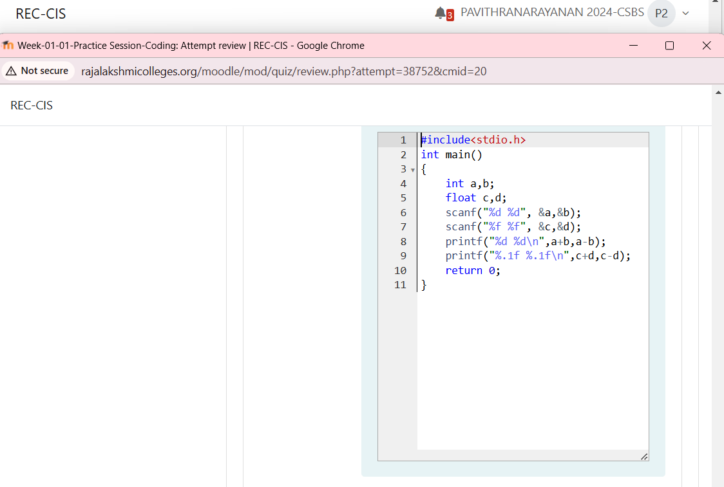
Output:
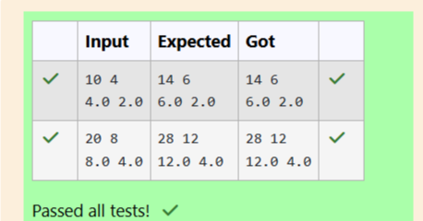
Question 4:
Write a program to input a name (as a single character) and marks of three tests as m1,m2, and m3 of a student considering all the three marks have been given in integer format.Now, you need to calculate the average of the given marks and print it along with the nameas mentioned in the output format section.All the test marks are in integers and hence calculate the average in integer as well. Thatis, you need to print the integer part of the average only and neglect the decimal part.
Program:
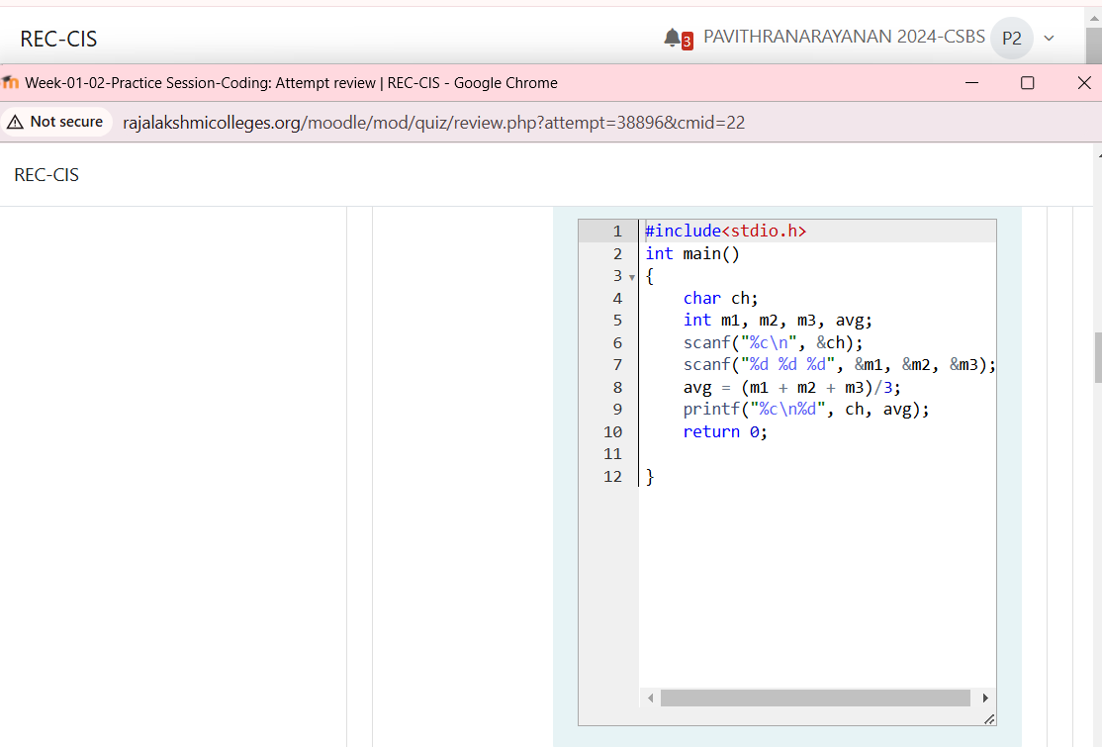
Output:
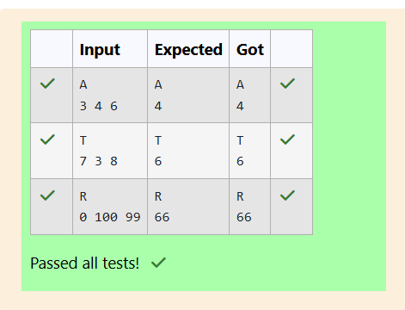
Question 5:
Some C data types, their format specifiers, and their most common bit widths are as
follows:
• Int ("%d"): 32 Bit integer
• Long ("%ld"): 64 bit integer
• Char ("%c"): Character type
• Float ("%f"): 32 bit real value
• Double ("%lf"): 64 bit real value
Program:
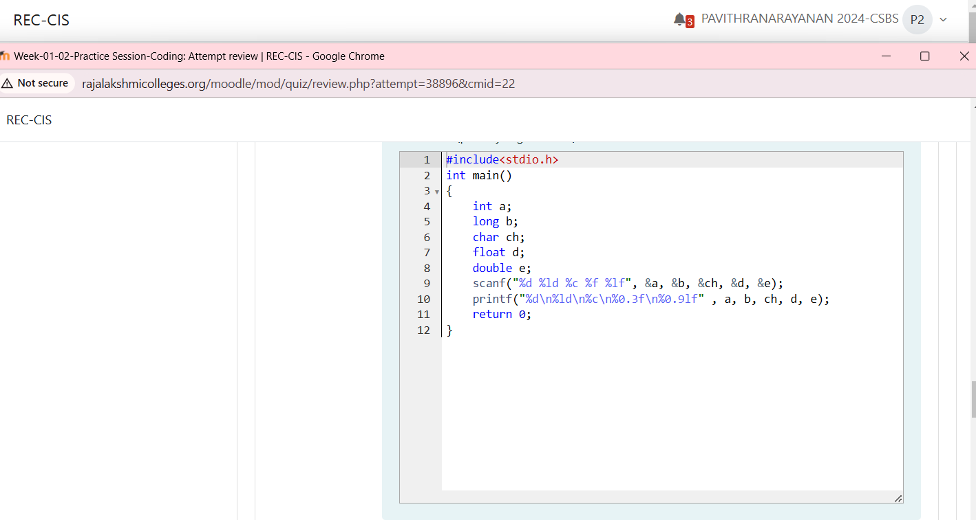
Output:
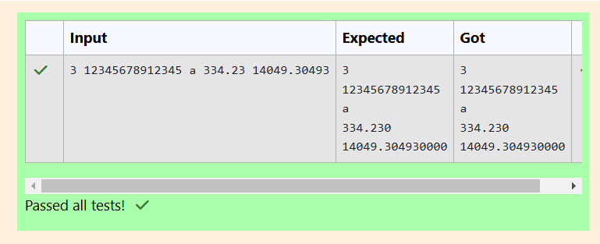

Question 6:
Write a program to print the ASCII value and the two adjacent characters of the given
character.

Input Format: Reads the character

Output Format: First line prints the ascii value, second line prints the previous character
and next character of the input character
Sample Input 1:
E
Sample Output 1:
69
D F
Program:
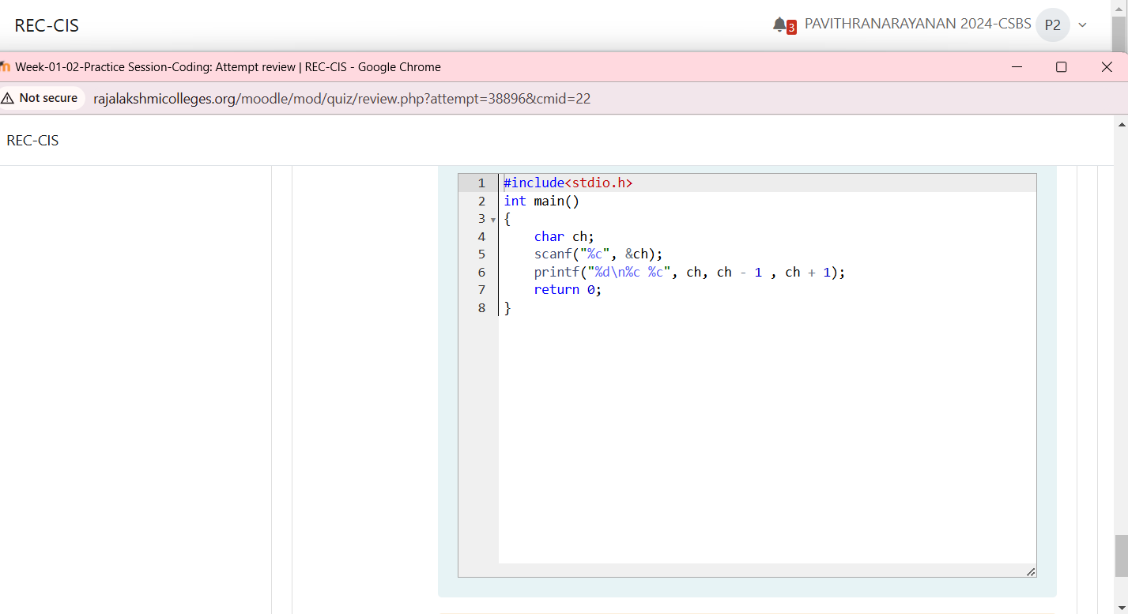
Output:
